Press release

Agricultural equipment, market at record pace

Registration figures released by FederUnacoma show, for the first six months of the year, increases of 52% for tractors and significant growth for all other types of vehicles. A positive phase also on foreign markets, with strong increases in the United States, India and Turkey. World trade is expected to grow by 7.3% over the next four years.

The Italian agricultural machinery market is moving at full speed. The data for the first half of the year - processed by FederUnacoma on the basis of the records provided by the Ministry of Transport - show significant increases for all categories of vehicles.
Tractor registrations were up more than 52% over the first half of 2020, with more than 12,500 units sold; combine harvesters were up almost 64% with 229 units sold, while flatbed tractors were up more than 31 percentage points with 327 units sold.
Record-breaking increases were also recorded for trailers, with 4,770 units up almost 40%, and for telehandlers, which showed an 85% increase with 755 machines sold.
The boom in registrations – as discussed during the FederUnacoma General Meeting, held this afternoon in Varignana (Bologna) - is partly due to the market recovery compared to the first half of 2020, characterised by the effects of the lockdown, but above all to an effective recovery of investments and tax incentives, such as those for machinery with 4.0 devices.
The positive trend, which is expected to continue in the second half of the year, was also recorded at the international level, with all the main markets performing well.
In the January-May period, the United States grew by nearly 26% compared to the same period in 2020, Canada increased by 51%, Turkey by 81% and India by 67%. In Europe, Germany grew by 15%, while the Spanish market (+42%) and the British market (+21%) also showed strong growth. The French market increased by 26% in the first five months of the year.
After ending 2020 with a global trade growth of 4.5%, the agricultural machinery sector is also forecasting a positive trend in the coming years: in the period between 2021 and 2024, the sector's trade is expected to increase by a total of 7.3%.

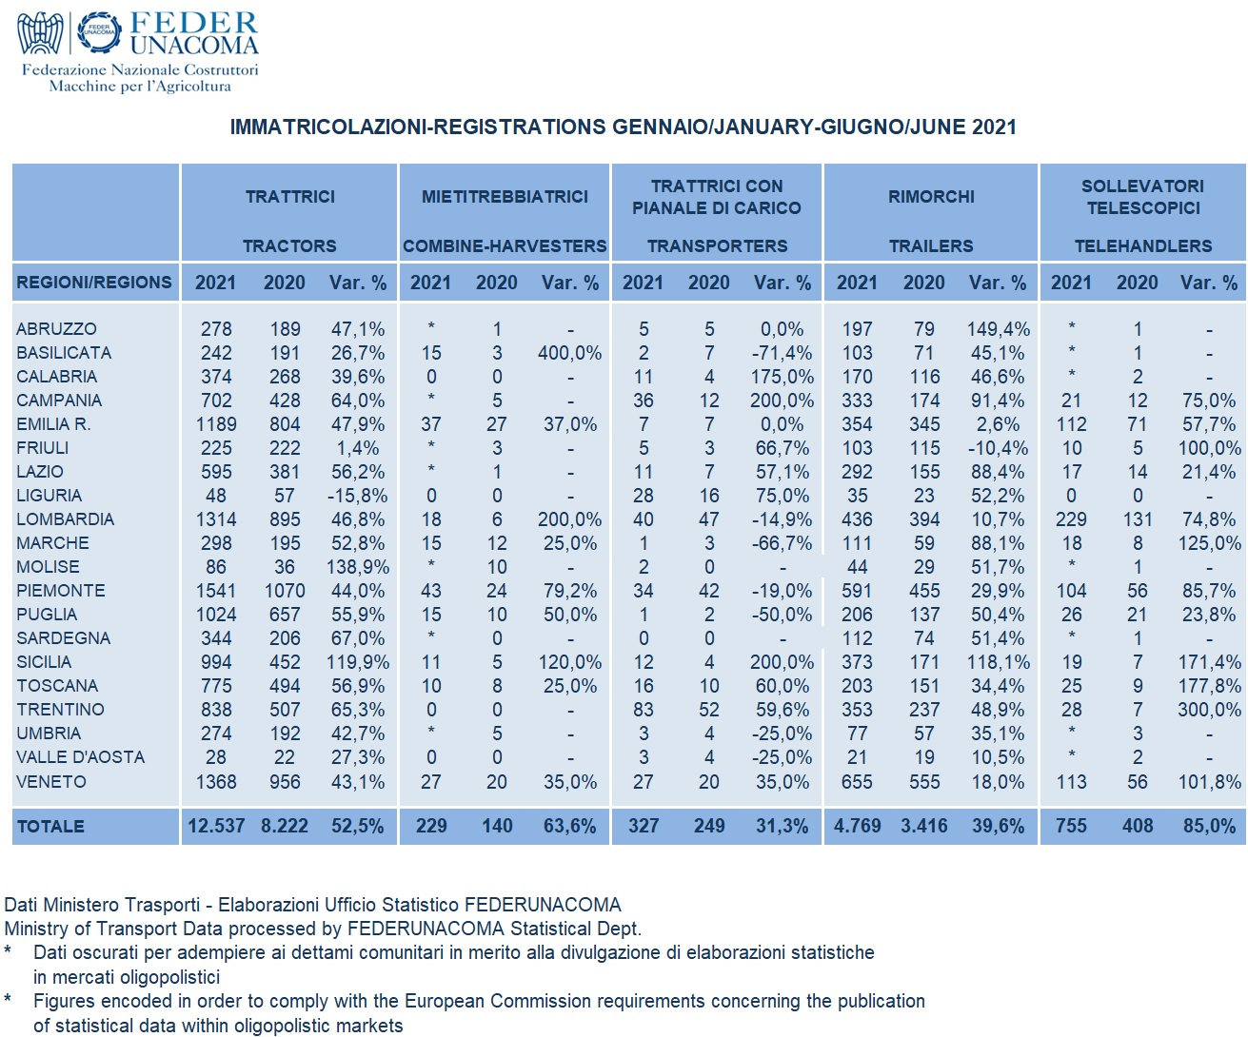

Bologna, 19 July 2021

