365FarmNet functions exclusively in CLAAS connect from November 2026
CLAAS scales farm management "Made in Berlin" globally and integrates 365FarmNet into the CLAAS organisation
Berlin, 28th November 2025. CLAAS has taken the Farm Management functions of 365FarmNet to a global level with CLAAS connect. As announced at Agritechnica 2023, the new CLAAS connect brings together CLAAS's many years of digital expertise. As part of this, the existing 365FarmNet platform will be completely replaced by CLAAS connect from November 2026. Users of 365FarmNet have been informed that the platform will remain available for a full year and will receive close support from CLAAS Sales during the transition to CLAAS connect. The 365FarmNet location in Berlin will continue to play a key role in the future as a software competence centre developing CLAAS's digital and autonomous solutions, alongside the CLAAS locations in Dissen and Herzebrock-Clarholz.

Since the launch of CLAAS connect on 1 October 2024, farmers in over 50 countries have had access to farm management functions "Made in Berlin". Extensive 365FarmNet functionalities in the areas of precision farming, documentation and fleet management have been taken to a new global level by the Berlin development teams in CLAAS connect.

Since its launch, CLAAS connect has been continuously expanded and developed as a future-oriented platform with mobile data access and a central link between machine and farm. CLAAS connect continuously opens up new opportunities for customers to optimise processes and operations as well as documentation, and scales established and new 365FarmNet applications connected with comprehensive digital CLAAS solutions in a global platform. In doing so, CLAAS has also responded to the wishes of many international customers who regularly requested 365FarmNet functions in their markets from our sales partners.

Digital CLAAS hotspot in the capital
Since 2013, 365FarmNet has been developing innovative and field-tested software solutions for farmers in the heart of Berlin. Starting out as developers of the 365FarmNet farm management platform, the development teams have been playing a key role in the development of the new CLAAS connect platform since 2020 – in close cooperation with the teams in Dissen and Herzebrock-Clarholz. The Berlin location's affiliation with CLAAS is also reflected in the company name: 365FarmNet became CLAAS 365FarmNet.

The location plays a decisive role in the further development of CLAAS's digital product portfolio: "The extensive expertise in holistic farm management solutions that the Berlin development teams have built up over many years is an important building block for the further development of our digital ecosystem and for solving complex requirements towards autonomy," emphasises Wolf-Christian von Wendorff, Senior Vice President Global Digital Solutions.

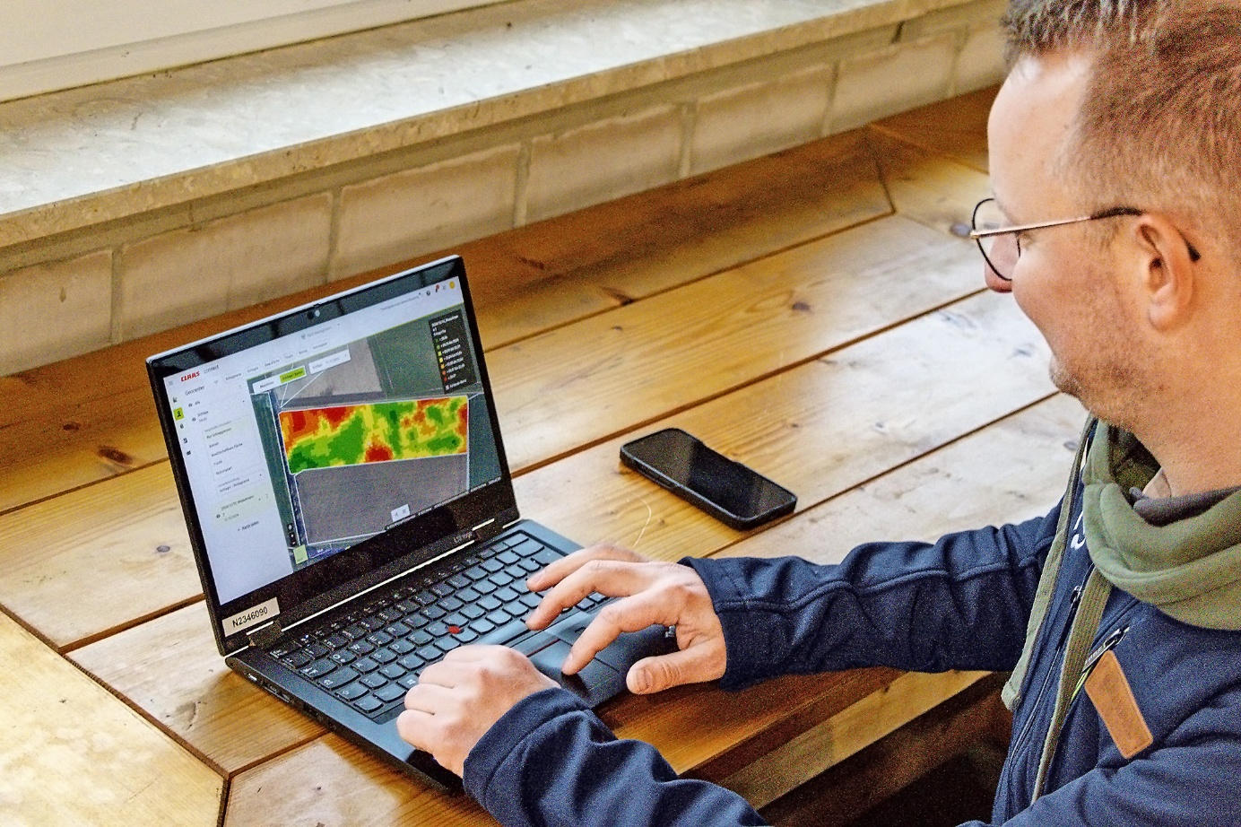
Many 365FarmNet applications are being elevated to a global level with CLAAS connect, such as the well-known comprehensive precision farming functionalities.

More than 100 CLAAS employees work at the Berlin site, including software engineers, product managers, quality experts, agile masters, the UX team, operations and support experts, and HR, finance, marketing and communications specialists.

Christian Radons, responsible for Service and Sales as well as customer digitalisation in the CLAAS Group Executive Board, explains the importance of the CLAAS office in the capital: "The Berlin location benefits from its location in Germany's IT capital. The international, dynamic and technology-oriented environment attracts digital talent and the brightest minds from all fields. CLAAS is proud of the diversity, commitment and digital expertise of its employees, who play a key role in shaping the digital future of CLAAS."

365FarmNet: from start-up to farm management benchmark
The company 365FarmNet was founded by CLAAS in 2013 – deliberately far away from its headquarters in order to give the small start-up the agility and independence it needed in the software sector. It quickly became clear that Berlin was the ideal location for IT companies and start-ups. In 2014, the company moved into its office on Hausvogteiplatz in the centre of Berlin, which is now an integrated CLAAS location.

The 365FarmNet platform was first presented at Agritechnica in Hanover in 2013. The approach: a farm management platform that covers and connects all areas of the business. This was something completely new at the time. The company quickly made a name for itself on the market and among customers and was able to enter partnerships with other companies. 365FarmNet set new benchmarks, particularly in applications for documentation, precision farming and fleet management: the start-up became an established software company in the agricultural sector, winning many awards and registering around 100,000 users over the years, mainly in Germany, France, Poland and Switzerland.

365FarmNet users find a new home in CLAAS connect
All 365FarmNet users have been informed that the platform will remain available for a full year – until the end of November 2026. Many customers have already switched to CLAAS connect in recent months. At Agritechnica, several hundred 365FarmNet customers also sought advice on switching options at a specially set up counter in the CLAAS connect area of the exhibition stand.

High-resolution images for print and web can be downloaded here:
https://dam.claas.com/pinaccess/pinaccess.do?pinCode=58K89goobuV7

About CLAAS
Founded in 1913, the family-owned company CLAAS (www.claas.com) is one of the world's leading manufacturers of agricultural machinery. Headquartered in Harsewinkel, Westphalia, the company is the global market leader in forage harvesters. CLAAS also holds the European market leadership in another core segment, combine harvesters. CLAAS also ranks among the world's top agricultural technology companies in the fields of tractors, agricultural balers and grassland harvesting machinery. Its product range also includes state-of-the-art agricultural information technology. CLAAS employs 12,000 people worldwide and achieved a turnover of 5 billion euros in the 2024 financial year.

