LEMKEN acquires the seeding technology specialist Equalizer

The family-owned company LEMKEN and the South African company Equalizer have reached an acquisition agreement. As a result, the German agricultural machinery specialist will be significantly expanding its product portfolio in seeding technology. With a focus on minimal ground disturbance to no-till farming, the Equalizer product range includes precision planters with up to 36 rows and seed drills with a working width of up to 24 metres. The acquisition is expected to be completed by spring 2023, once regulatory approvals have been obtained.

LEMKEN CEO Anthony van der Ley believes that the Equalizer portfolio perfectly complements the LEMKEN seed drill segment and constitutes an important building block for further growth. “There is no overlap in our portfolios. Equalizer offers solutions for customers and markets that LEMKEN has not been able to serve so far. In terms of our growth strategy, the Equalizer planters and seeders – also in combination with air carts – close a current gap in our product range.” An additional, optimal synergy arises for LEMKEN precision seeding technology, as the Delta-Row technology developed by LEMKEN is complemented by single-row technology established by Equalizer.

Equalizer, which is also a family business, was founded in Cape Town in 2000 and currently employs 180 people. The company serves not only its South African home market, where it is the market leader in precision seeding, but also Australia as its most important export market. “We see great potential for new products with LEMKEN on our side, and we look forward to our future collaboration. At the same time, we are proud that this agreement reaffirms the success and hard work of the entire Equalizer team and our local dealers over the past 22 years,” says Gideon Schreuder, Equalizer’s founder and managing director, emphasising that Equalizer will continue to support its customers as an innovative and reliable partner.

LEMKEN is committed to this promise and wants to expand the South African site together with Equalizer. The first definite project is the extensive expansion of spare parts logistics in 2023. All of Equalizer’s experienced local staff will be retained. Equalizer will continue to be led as an independent subsidiary by its current management, and the brand name will be preserved. Of course, the German agricultural machinery specialist will contribute its development, production and sales expertise to support Equalizer’s future growth.

***
About LEMKEN: LEMKEN enjoys a worldwide reputation as a visionary, sustainably operating company that makes an important contribution to profitable agriculture. A medium-sized German family company, LEMKEN has applied its expertise and passion for progress for 243 years, delivering solutions for the challenges confronting agriculture today and tomorrow. The company’s product range includes tillage implements, seed drills, hoeing machines, fertiliser spreaders and smart solutions for agricultural data management.

Press Contact

Marie Ehses
Phone +49 2802 81 - 250
m.ehses@lemken.com
www.lemken.com

Image 1: LEMKEN CEO Anthony van der Ley, owner Nicola Lemken and Equalizer Managing Director Gideon Schreuder after signing the contract
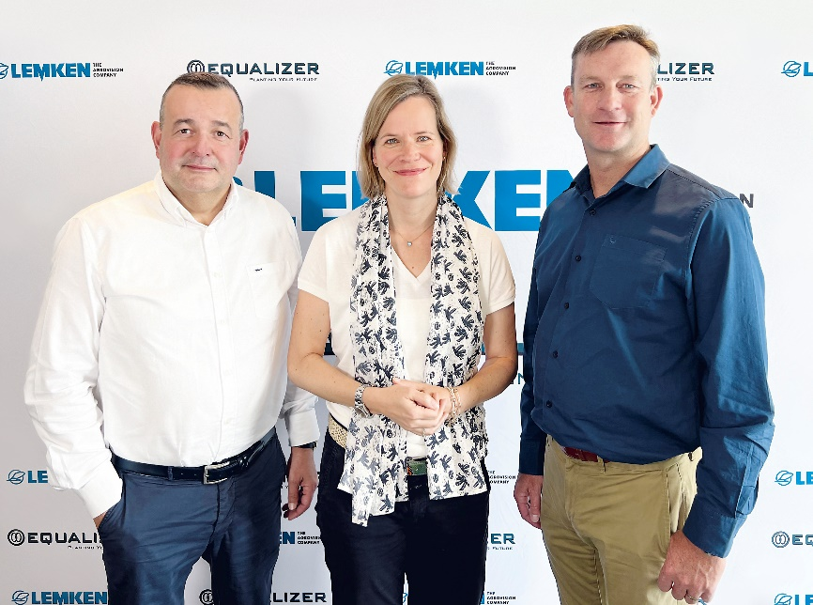

Image 2: Equalizer seed drill with Air Cart
