LEMKEN delivers strong growth

Innovations and image contribute to record sales

LEMKEN, the specialist for professional arable farming, continued its growth trajectory during the past financial year. The family business, which has a 243-year history, set yet another record by increasing its sales by 25 percent to an estimated €559 million. The new year started with a high level of orders on the books.

“We were able to increase our sales and result once again, despite global supply chain problems and increasing rates of inflation,” said partner Nicola Lemken and CEO Anthony van der Ley as they presented the preliminary sales figures. Incoming orders have exceeded expectations. 2022 also confronted farmers with many challenges, but overall, farmers were able to use high producer prices to invest in professional agricultural technology, even though input prices had increased.

All over the world, LEMKEN benefits from its excellent image in the industry. It successfully expanded its sales further in both its home market of Germany and in its international business. “We are currently already generating 80 percent of our sales from our export business and believe that there is potential for further growth as we explore new markets and target groups,” said CEO Anthony van der Ley. Products such as the new Karat 10 cultivator and new plough models have also driven additional demand.

In order to achieve its ambitious goals, LEMKEN is investing not only in a new facility in Dinteloord (manufacture of modern precision hoeing technology), but also the expansion of its Haren facility (assembly of seed drill technology) and its Excellence programme (optimisation of production and assembly) in Alpen. Another major contribution to the company’s success is to be made by the company’s acquisition of Equalizer, a South African specialist for precision seed drills with a focus on minimal tillage and no-till farming for large-scale farms.

LEMKEN continues to focus on its employees, whose commitment constitutes an essential part of the success of this family business. During the past financial year, LEMKEN increased the number of its employees worldwide by 4.5 percent to 1,773. To keep up with its strong growth and maintain its high standing as a partner for farmers, LEMKEN continuously looks for qualified specialists for all parts of its business.

The company expects that its positive business development will continue in 2023, based on the already high level of existing orders. While farmers will likely benefit from the ongoing positive market situation, European agricultural policy and the expectation of additional regulation in particular will create additional concerns for EU-based farmers compared to international producers. This year’s Agritechnica, the world’s leading trade fair for agricultural technology, which will be held in Hanover in November 2023, will likely showcase an impressive array of innovations across the entire product portfolio. LEMKEN additionally lives up to its mission as the AgroVision Company by investing in future-oriented issues such as autonomous drive units or carbon farming.

***
About LEMKEN: LEMKEN enjoys a worldwide reputation as a visionary, sustainably operating company that makes an important contribution to profitable agriculture. A medium-sized German family company, LEMKEN has applied its expertise and passion for progress for 243 years, delivering solutions for the challenges confronting agriculture today and tomorrow. The company’s product range includes tillage implements, seed drills, hoeing machines, fertiliser spreaders and smart solutions for agricultural data management.

Press Contact

Marie Ehses
Phone +49 2802 81 - 250
m.ehses@lemken.com
www.lemken.com

Fig. 1: Ground-breaking ceremony at the new site for mechanical weed control technology in Dinteloord (NL).
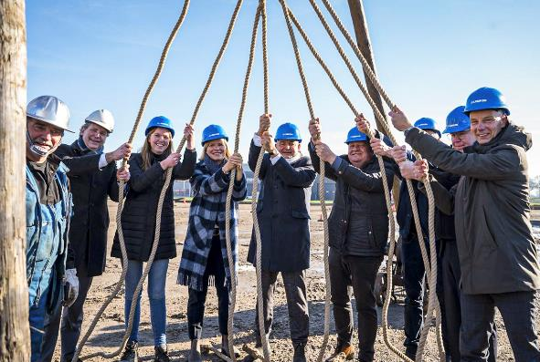

Fig. 2: Motivated employees working at modern workstations produce high-quality machines for exacting farmers.
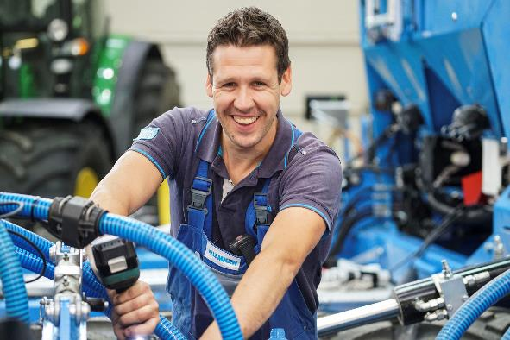

Fig. 3: The Solitair DT was presented on the occasion of the 25th anniversary of LEMKEN seed drill technology.
